Activity | Data Type
Number of beatings from Wife | Discrete
Results of rolling a dice | Discrete
Weight of a person | Continuous
Weight of Gold | Continuous
Distance between two places | Continuous
Length of a leaf | Continuous
Dog's weight | Continuous
Blue Color | Discrete
Number of kids | Discrete
Number of tickets in Indian railways | Discrete
Number of times married | Discrete
Gender (Male or Female) | Discrete
Q1) Identify the Data type for the Following:

Q2) Identify the Data types, which were among the following
Nominal, Ordinal, Interval, Ratio.
Data | Data Type
Gender | Nominal
High School Class Ranking | Ordinal
Celsius Temperature | Ratio
Weight | Interval
Hair Color | Nominal
Socioeconomic Status | Nominal
Fahrenheit Temperature | Ratio
Height | Interval
Type of living accommodation | Ordinal
Level of Agreement | Nominal
IQ(Intelligence Scale) | Interval
Sales Figures | Interval
Blood Group | Nominal
Time Of Day | Ordinal
Time on a Clock with Hands | Nominal
Number of Children | Nominal
Religious Preference | Ordinal
Barometer Pressure | Ratio
SAT Scores | Interval
Years of Education | Interval

Q3) Three Coins are tossed, find the probability that two heads and one tail are obtained?
Ans) 3/8
Q4) Two Dice are rolled, find the probability that sum is
- Equal to 1 = 0
- Less than or equal to 4 =1/6
- Sum is divisible by 2 and 3 = 1/6

Q5) A bag contains 2 red, 3 green and 2 blue balls. Two balls are drawn at random. What is the probability that none of the balls drawn is blue?
Ans ) 10/21
Q6) Calculate the Expected number of candies for a randomly selected child
Below are the probabilities of count of candies for children (ignoring the nature of the child-Generalized view)
CHILD | Candies count | Probability
A | 1 | 0.015
B | 4 | 0.20
C | 3 | 0.65
D | 5 | 0.005
Ex | 6 | 0.01
F | 2 | 0.120
Child A – probability of having 1 candy = 0.015.
Child B – probability of having 4 candies = 0.20
Ans ) 3.09

Q7) Calculate Mean, Median, Mode, Variance, Standard Deviation, Range & comment about the values / draw inferences, for the given dataset
- For Points,Score,Weigh>
Find Mean, Median, Mode, Variance, Standard Deviation, and Range and also Comment about the values/ Draw some inferences.
Use Q7.csv file

Points | Score | Weigh
3.9 | 2.62 | 16.46
3.9 | 2.875 | 17.02
3.85 | 2.32 | 18.61
3.08 | 3.215 | 19.44
3.15 | 3.44 | 17.02
2.76 | 3.46 | 20.22
3.21 | 3.57 | 15.84
3.69 | 3.19 | 20
3.92 | 3.15 | 22.9
3.92 | 3.44 | 18.3
3.92 | 3.44 | 18.9
3.07 | 4.07 | 17.4
3.07 | 3.73 | 17.6
3.07 | 3.78 | 18
2.93 | 5.25 | 17.98
3 | 5.424 | 17.82
3.23 | 5.345 | 17.42
4.08 | 2.2 | 19.47
4.93 | 1.615 | 18.52
4.22 | 1.835 | 19.9
3.7 | 2.465 | 20.01
2.76 | 3.52 | 16.87
3.15 | 3.435 | 17.3
3.73 | 3.84 | 15.41
3.08 | 3.845 | 17.05
4.08 | 1.935 | 18.9
4.43 | 2.14 | 16.7
3.77 | 1.513 | 16.9
4.22 | 3.17 | 14.5
3.62 | 2.77 | 15.5
3.54 | 3.57 | 14.6
4.11 | 2.78 | 18.6

Points Score Weigh count32.00000032.00000032.000000 mean 3.5965633.21725017.848750 std 0.5346790.9784571.786943 min 2.7600001.51300014.500000 25% 3.0800002.58125016.892500 50% 3.6950003.32500017.710000 75% 3.9200003.61000018.900000 max 4.9300005.42400022.900000
Q8) Calculate Expected Value for the problem below
- The weights (X) of patients at a clinic (in pounds), are
108, 110, 123, 134, 135, 145, 167, 187, 199
Assume one of the patients is chosen at random. What is the Expected Value of the Weight of that patient?

Ans) 145.3333

Q9) Calculate Skewness, Kurtosis & draw inferences on the following data
Cars speed and distance
Use Q9_a.csv
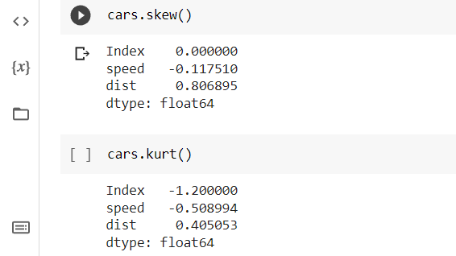
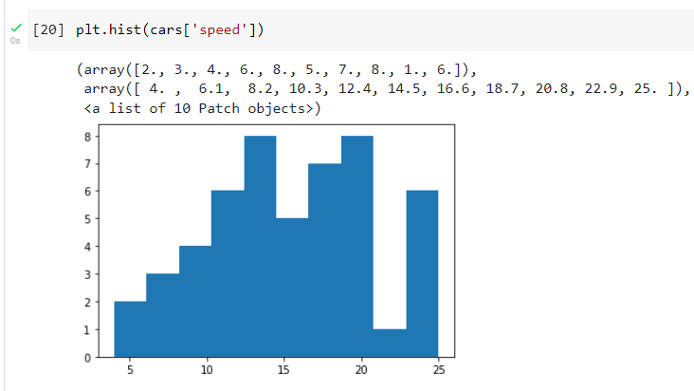
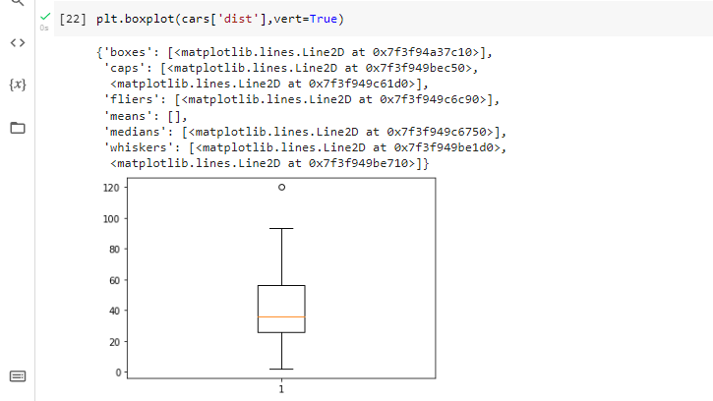

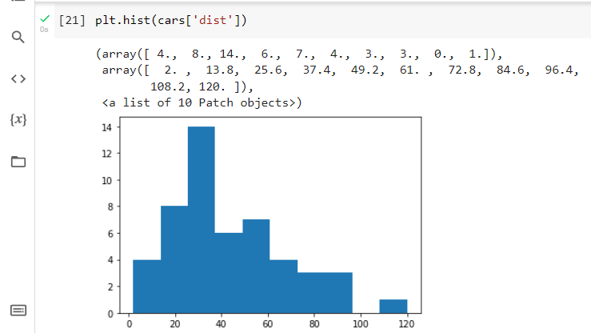
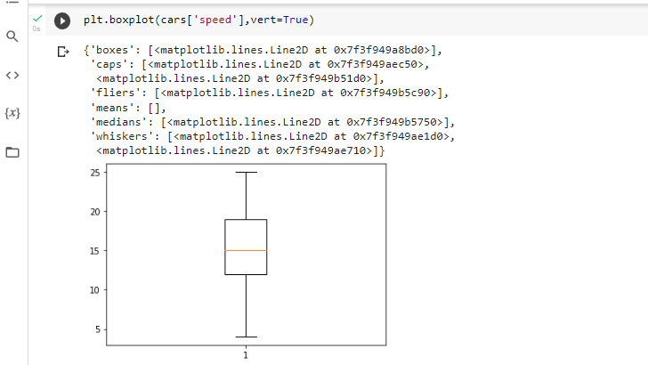

SP and Weight(WT)
Use Q9_b.csv
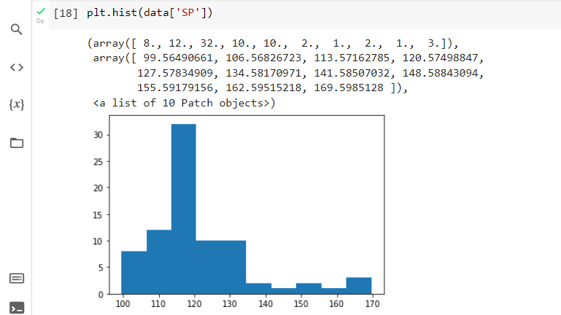
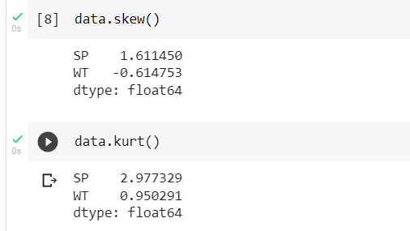

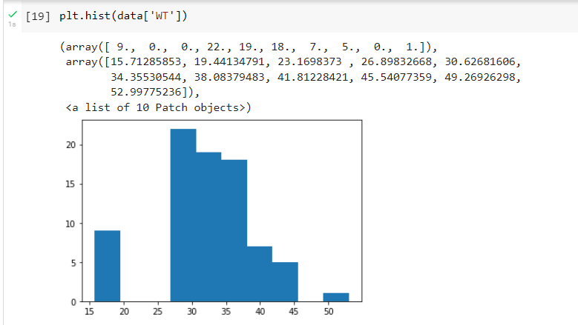

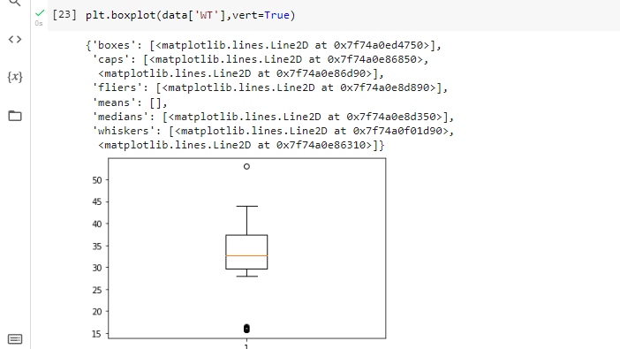
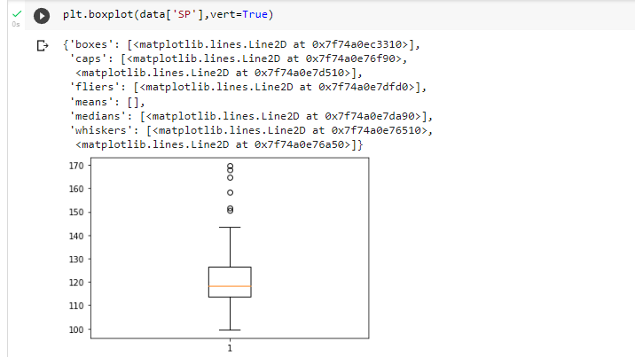

Q10) Draw inferences about the following boxplot & histogram
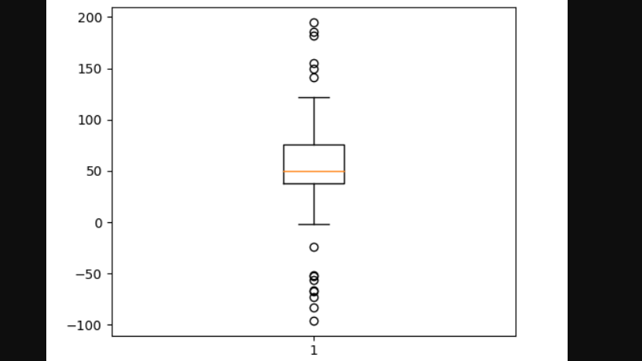

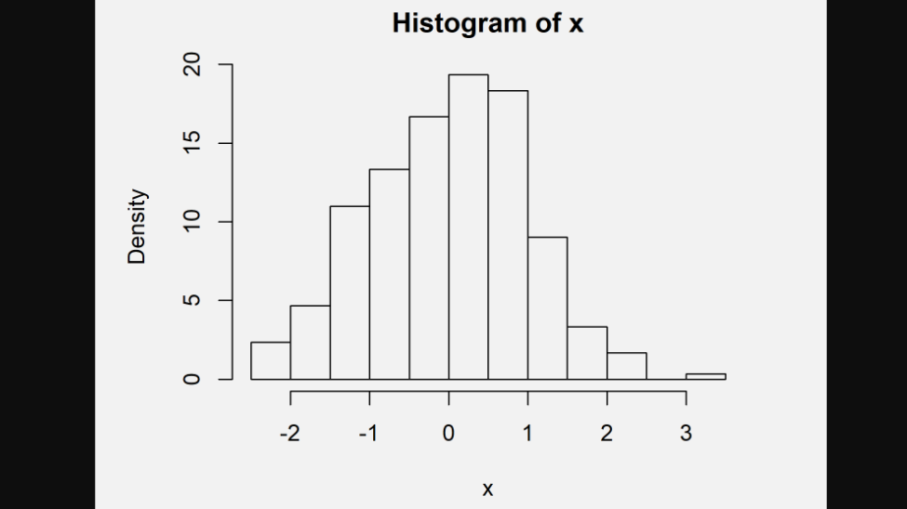

Q11) Suppose we want to estimate the average weight of an adult male in Mexico. We draw a random sample of 2,000 men from a population of 3,000,000 men and weigh them. We find that the average person in our sample weighs 200 pounds, and the standard deviation of the sample is 30 pounds. Calculate 94%,98%,96% confidence interval?

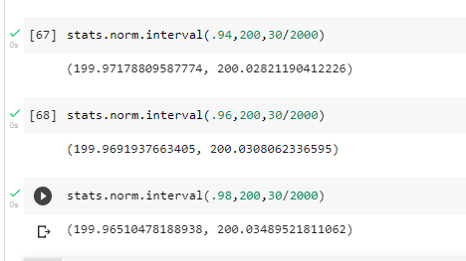
Q12) Below are the scores obtained by a student in tests
34,36,36,38,38,39,39,40,40,41,41,41,41,42,42,45,49,56
- Find mean, median, variance, standard deviation.
- What can we say about the student marks?
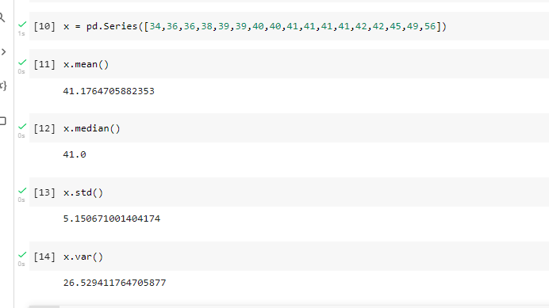
Q13) What is the nature of skewness when mean, median of data are equal?
Ans ) measure of a symmetry in the distribution.

Q14) What is the nature of skewness when mean > median ?
Ans ) Negative skewness implies mass of the distribution concentrated on right side.
Q15) What is the nature of skewness when median > mean?
Ans ) possitive skewness implies mass of the distribution concentrated on left side.
Q16) What does positive kurtosis value indicates for a data ?
Ans ) positive kurtosis value indicates that thinner peak and wider tail.
Q17) What does negative kurtosis value indicates for a data?
Ans ) negative kurtosis value indicates that wider peak and thinner tail.

Q18) Answer the below questions using the below boxplot visualization.
What can we say about the distribution of the data?
What is nature of skewness of the data?
What will be the IQR of the data (approximately)?
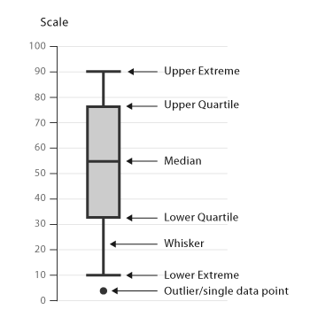

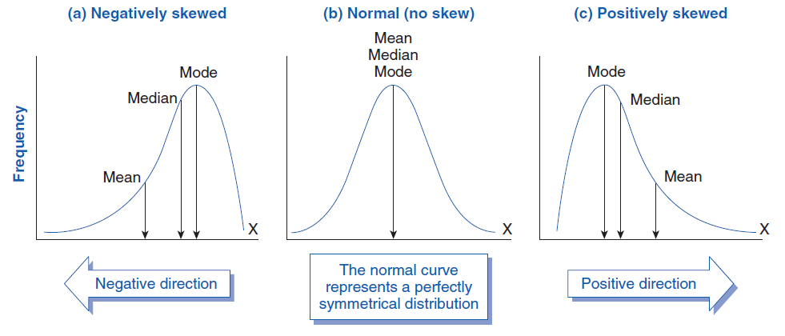

c ) Inter Quartile range =the middle half of a data set falls within the inter quartile range
IQR = UQ-LQ

Q19) Comment on the below Boxplot visualizations?

Draw an Inference from the distribution of data for Boxplot 1 with respect Boxplot 2.
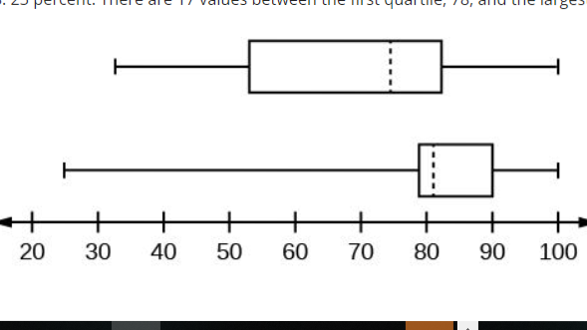
Q 20) Calculate probability from the given dataset for the below cases

Data _set: Cars.csv
Calculate the probability of MPG of Cars for the below cases.
MPG <- Cars$MPG
  - P(MPG>38)
  - P(MPG<40)
c. P (20<MPG<50)
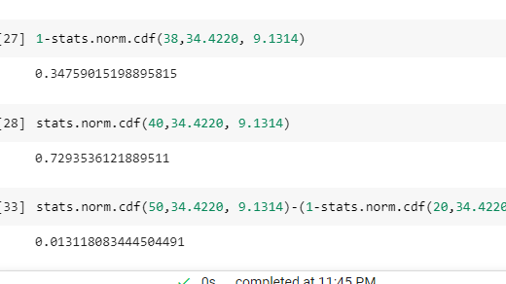
Q 21) Check whether the data follows normal distribution
- Check whether the MPG of Cars follows Normal Distribution
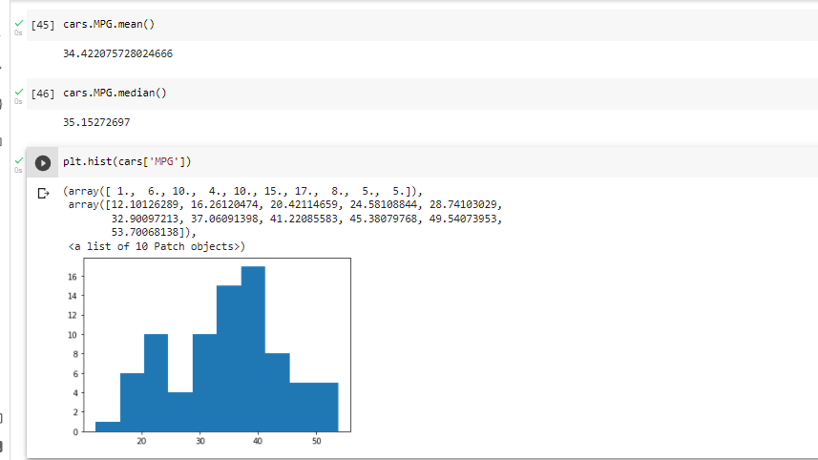
Dataset: Cars.csv

- Check Whether the Adipose Tissue (AT) and Waist Circumference(Waist) from wc-at data set follows Normal Distribution
Dataset: wc-at.csv

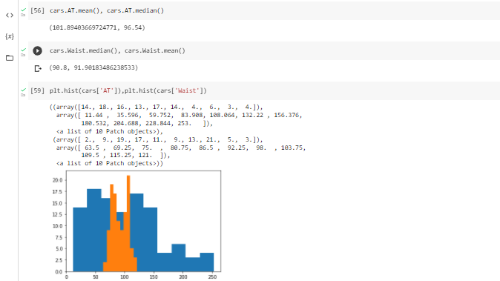
Q 22) Calculate the Z scores of 90% confidence interval,94% confidence interval, 60% confidence interval

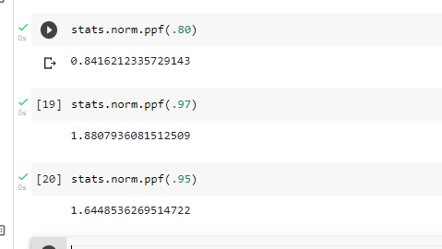

Q 23) Calculate the t scores of 95% confidence interval, 96% confidence interval, 99% confidence interval for sample size of 25
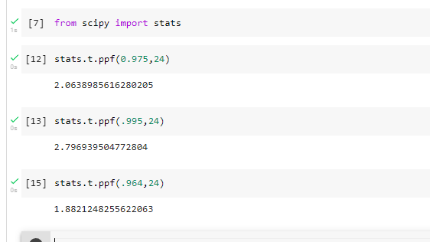

Q 24) A Government company claims that an average light bulb lasts 270 days. A researcher randomly selects 18 bulbs for testing. The sampled bulbs last an average of 260 days, with a standard deviation of 90 days. If the CEO's claim were true, what is the probability that 18 randomly selected bulbs would have an average life of no more than 260 days
Hint:
rcode → pt(tscore,df)
df → degrees of freedom

